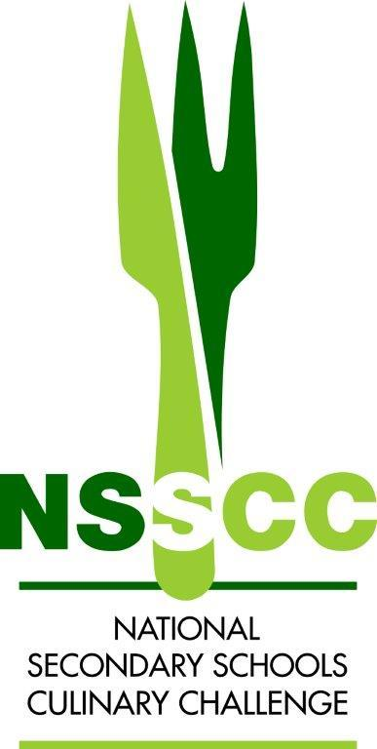

**NSSCC Regional Online Competition**

**Recipe Template 2025** 





| **School:** |  | |
| --- | --- | --- |
| **Team Name:** |  | |
| **Competitors:** | **1.** | **2.** |

**Course: Entrée Portions: 2**

| **Weight** | **Ingredient** |  | **Weight** | **Ingredient** |
| --- | --- | --- | --- | --- |
|  |  |  |  |  |
|  |  |  |  |  |
|  |  |  |  |  |
|  |  |  |  |  |
|  |  |  |  |  |
|  |  |  |  |  |
|  |  |  |  |  |
|  |  |  |  |  |
|  |  |  |  |  |

**Method:**

| **Step/Timing**  e.g  1. 5-10 mins | Dice onions and saute in butter with garlic until translucent |
| --- | --- |
|  |  |

**School Team Name:**

| **Step/Timing** |  |
| --- | --- |
|  |  |





